Data Flow Diagram (DFD)

A Data Flow Diagram (DFD) is a graphical representation of how information moves through a system. It illustrates the flow of data between users, system processes, and data storage. In the Metro Ticket Generating System, the DFD helps visualize how passenger information is collected, processed, stored, and retrieved using the ServiceNow platform. It provides a clear understanding of the interaction between the Service Portal, Flow Designer, Metro Database, and QR code generation process.
The purpose of the Data Flow Diagram is to explain the movement of information within the Metro Ticket Generating System. It demonstrates how passenger inputs are processed through ServiceNow automation and how the generated ticket details are securely stored in the Metro Database. This representation simplifies system analysis and helps developers, testers, and stakeholders understand the application’s internal workflow.

Data Flow Description
The booking process begins when a passenger accesses the Service Portal and opens the Book a Metro Ticket catalog item. The passenger enters journey details such as the source station, destination station, passenger type, journey type, and the number of passengers. These inputs are validated using Catalog Client Scripts and UI Policies to ensure data accuracy.
Once the passenger submits the booking request, Flow Designer is automatically triggered. It retrieves all catalog variables, calculates the fare based on the selected journey, and creates a record in the custom Metro Database table. After the record is successfully created, the system generates a QR code that acts as the digital metro ticket. The passenger receives confirmation of the booking and uses the QR code during travel.

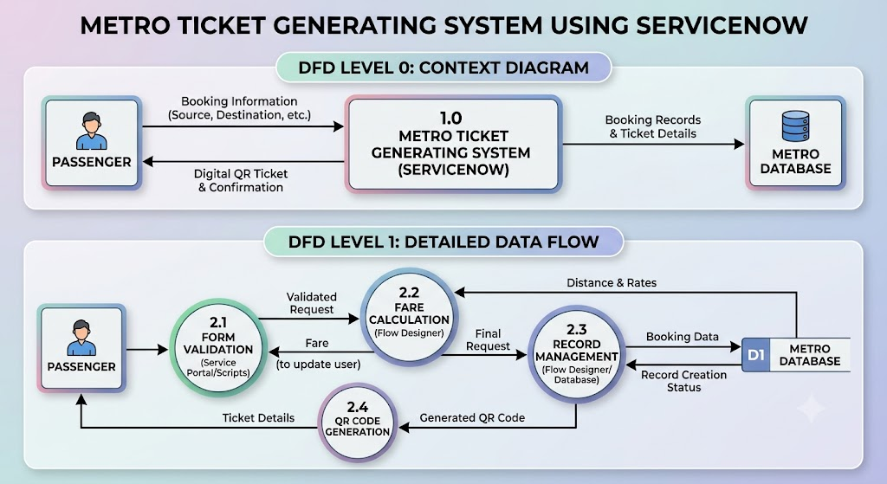

DFD Level 0 Explanation
The Level 0 Data Flow Diagram represents the Metro Ticket Generating System as a single process interacting with external entities. The passenger provides booking information to the system, and in return, receives a digital QR ticket. Simultaneously, the system stores all booking information in the Metro Database for future reference and reporting.

DFD Level 1 Explanation
The Level 1 Data Flow Diagram expands the internal processes of the application. It includes form validation, fare calculation, Flow Designer automation, record creation, QR code generation, and secure data storage. Each process works together to ensure that ticket booking is completed accurately and efficiently while maintaining data integrity and security.

